May, 2016

To,
Editorial Coordinator,
Research & Reviews: Journal of Material Sciences

Subject: Accepting the Editorial Board Member position of Research & Reviews: Journal of Material Sciences

Dear Journal Coordinator,

I would like to serve as an Editorial Board Member for journal, Research & Reviews: Journal of Material Sciences, a renowned periodical in material sciences and allowing the journal to display my affiliation details at journal’s website.

I am happy to render my continuous support and suggestion(s) for the betterment of journal in favoring the dissemination of scientific knowledge for the respective research community.

Best wishes,
Regards,

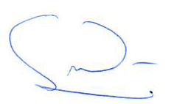

Name: Daniel A. Lowy, Ph.D.
Designation: Sr. Research Scientist and Adjunct Associate Professor
Current Affiliation: FlexEl, LLC (College Park, Maryland) and NOVA University (Alexandria Virginia)
Country: USA
Contact Email: daniellowy@gmail.com
Contact Number: +1-703-517 9636 (Cell)

Suggestion or proposal:

- Microstructured electrode materials
- Advances in the preparation and use of solid polymer electrolytes (SPEs)

